Retrieving Data Using the SQL Select Statement
- Determine the structure of DEPT table and its contents.
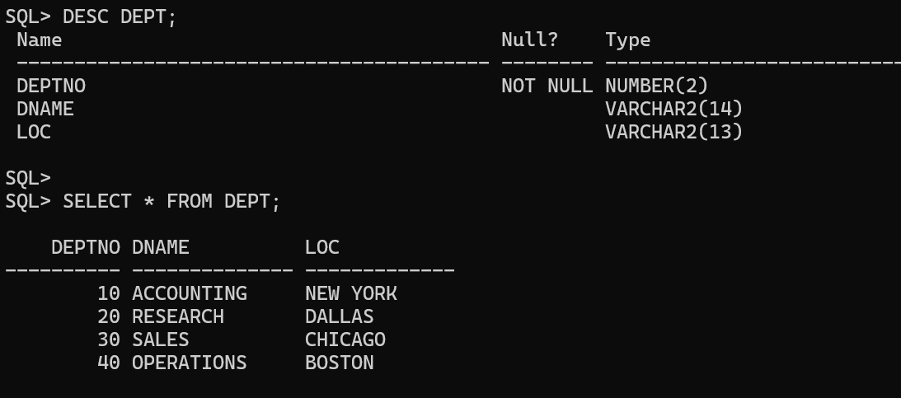

- Determine the structure of EMP table and its contents.
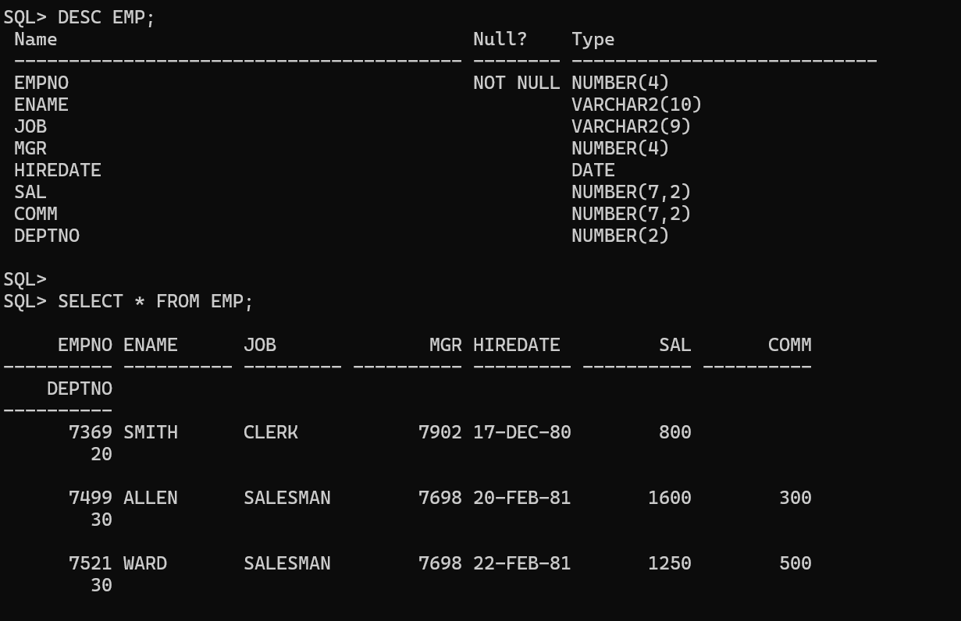

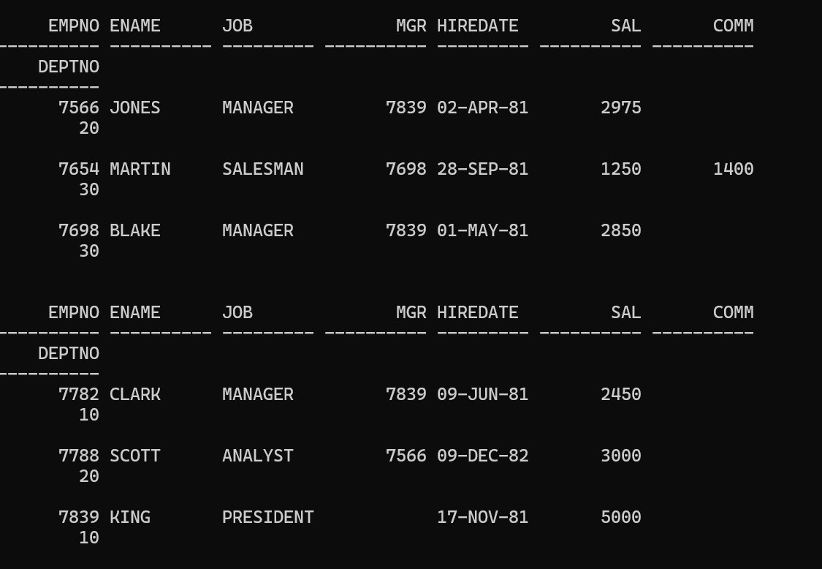

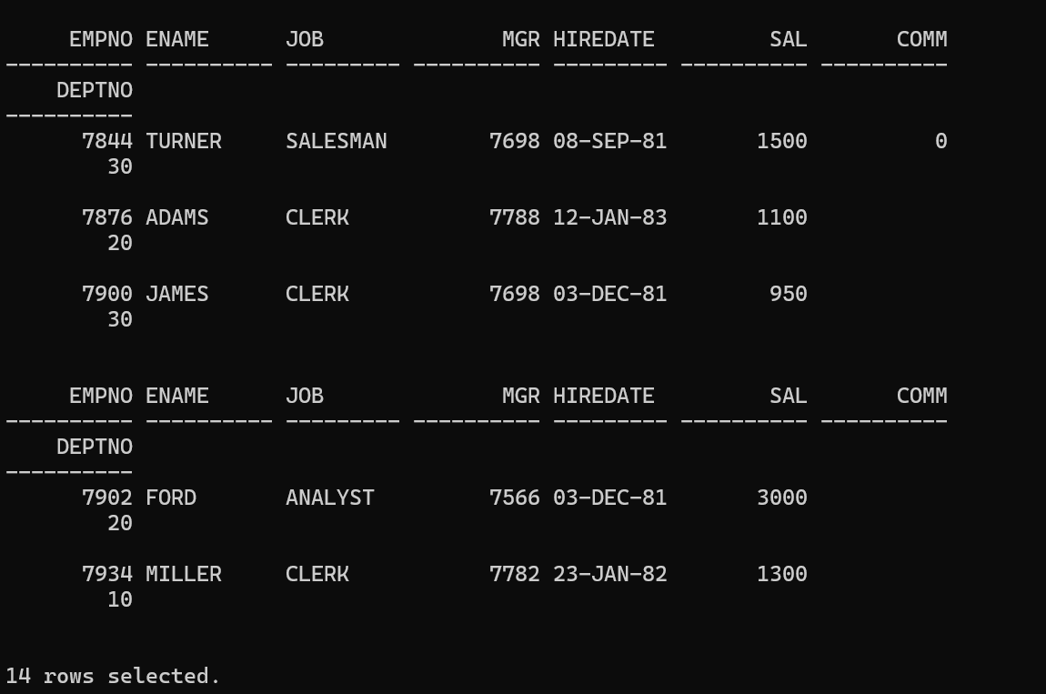

- Display the ENAME and DEPTNO from EMP table whose EMPNO is 7788.
